ReadMe Document

**TTA** is an independent product that provides a way to do Trend Analysis across your test suites.

On the consumer front, TTA consumes xUnit based results and other raw data from across your projects and test frameworks and archives it. On the view front, TTA provides some simple reports, and a way to create custom reports that displays Test Trends for you. QA Manager can know the relative health of all his projects without having to collate the data manually.

Installation Steps:

1. Install ruby and Rails.
2. Install Bundler and Run the bundle of commands.
3. Hit the server with the given static IP and run the rake task.

TTA Overview:

1. Testing trend analysis homepage has 3 options:
   1. To upload data
   2. To perform comparative analysis
   3. To view the test pyramid
2. Upload sub project specific data.
   1. Use: To view graphs and other analysis results, the data required is entered manually through this page. This form is used to manually enter the details and logs for tests that have to be uploaded onto TTA.
   2. Enter all the data asked in the form corresponding to the files, which you want to upload.
   3. Choose to file that has to be uploaded.
   4. Submit it and if the project is saved successfully, then a message is shown.

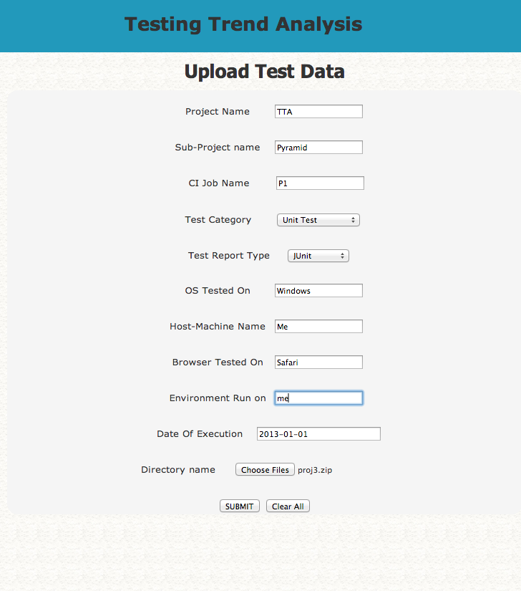

1. View pyramid

Use: Test pyramid shows the % of different test types run.

* 1. Choose a sub-project whose pyramid you want to view and plot.

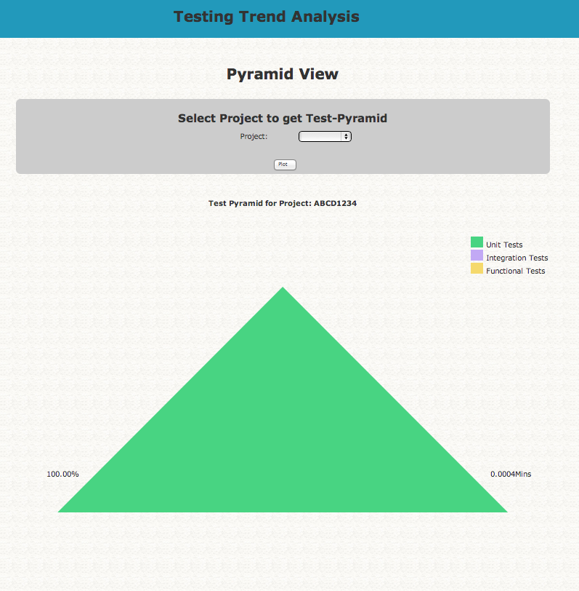

1. View a comparative analysis
   1. Choose the time period, whose.
   2. Choose the project.
   3. Select plot.

LIMITATIONS AND ASSUMPTIONS:

FAQ: